**ASSIGNMENT-9**

**H.NO:2403A52139**

* **TASK-1:**

Write python function to return sum of even and odd numbers in the given list.

**GEMINI CODE AND OUTPUT WITHOUT COMMENTS AND DOCSTRING :**

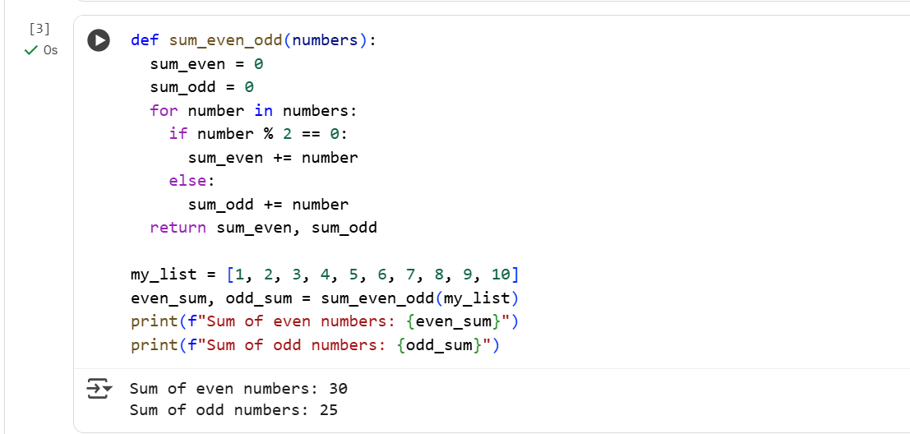

**CODE WITH DOCSTRING:**

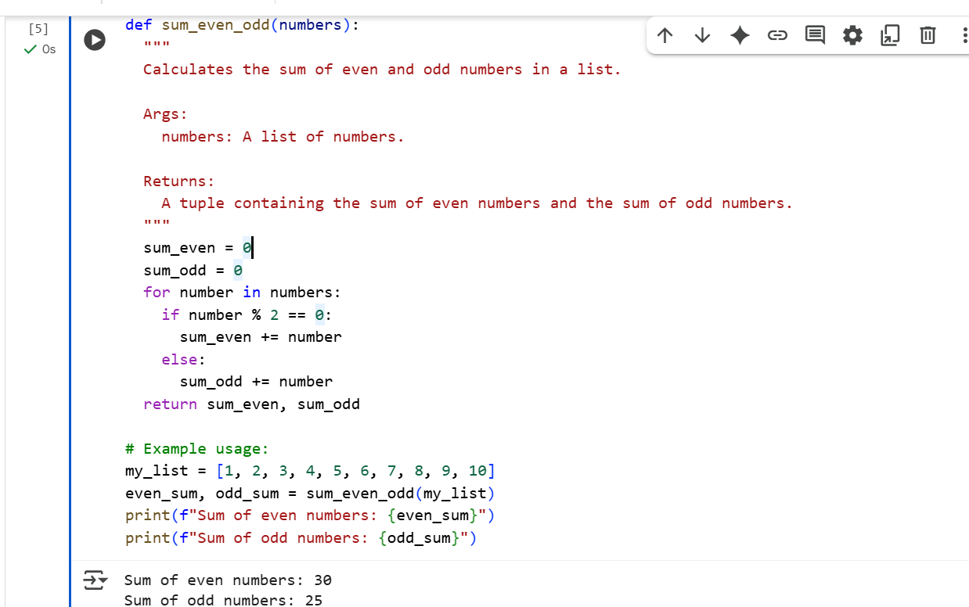

**VS CODE WITHOUT DOCSTRING:**

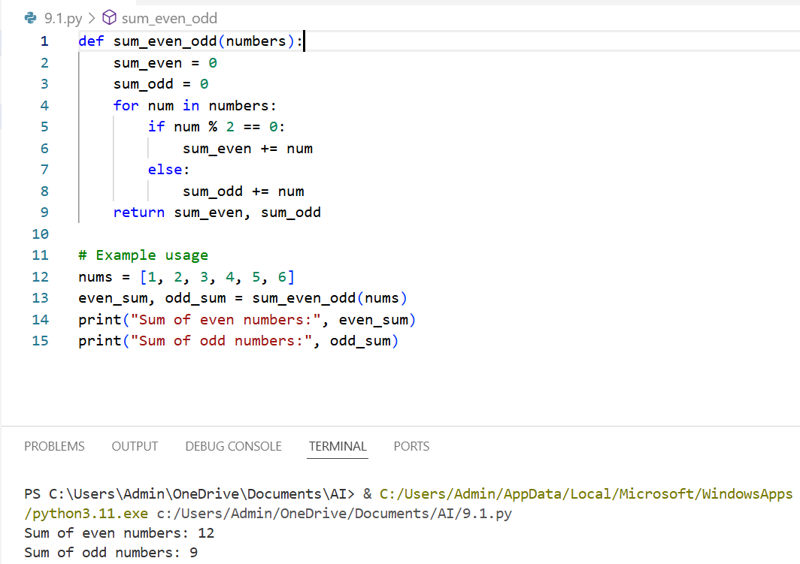

**VS CODE WITH DOCSTRING:**

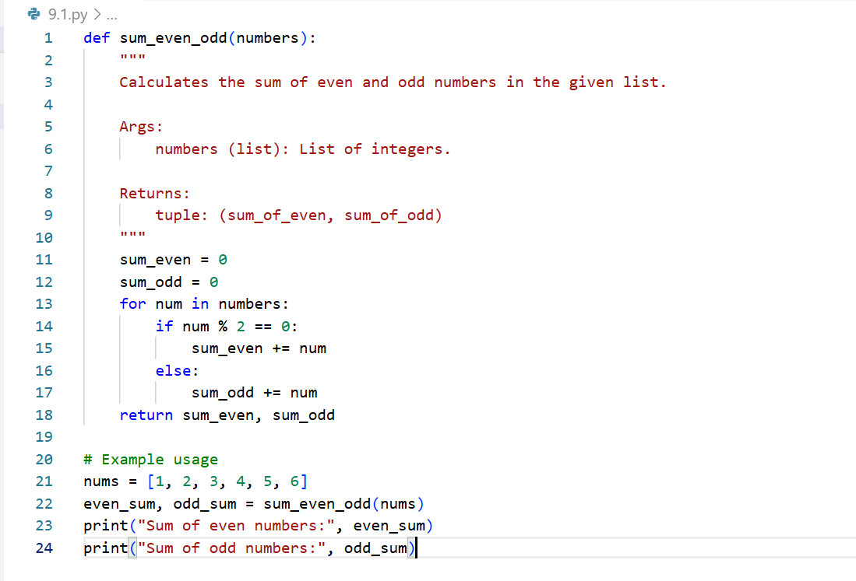

* **TASK-2**

Description#2 Automatic Inline Comments

* Write python program for sru_student class with attributes like name, roll no., hostel_status and fee_update method and display_details method.

**GEMINI CODE WITHOUT INLINECOMMENTS AND DOCSTRING :**

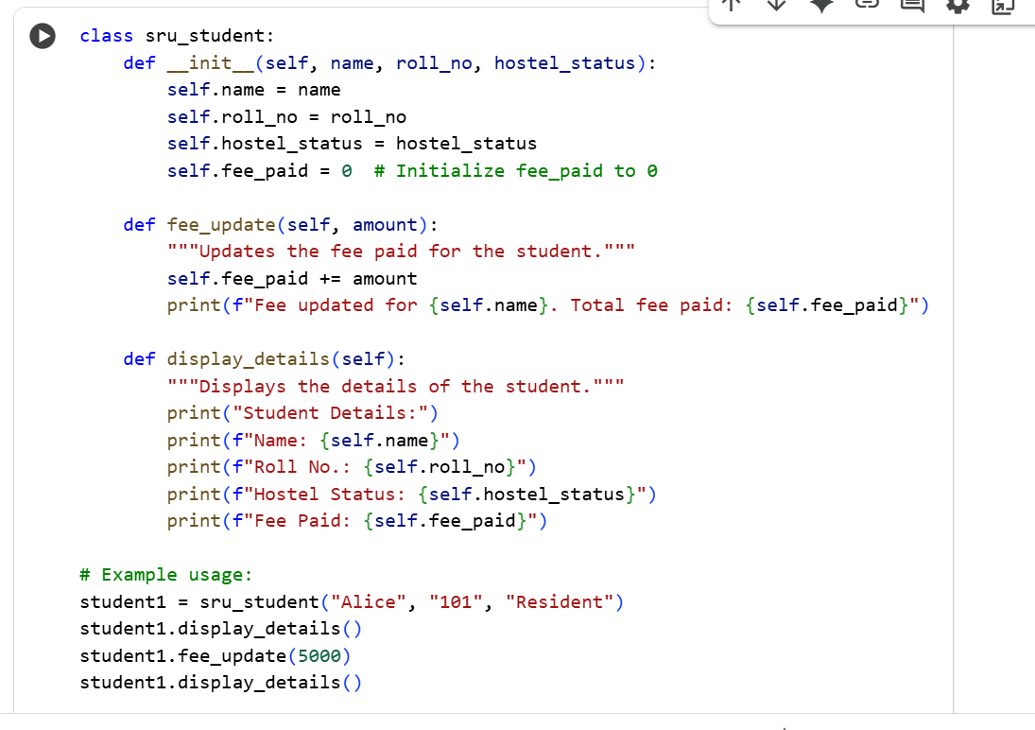

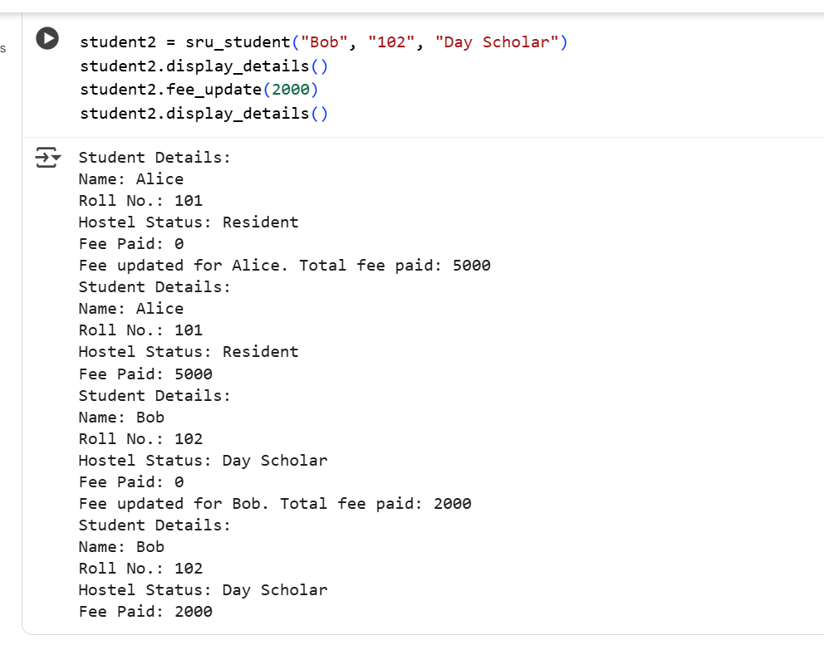

**CODE WITH INLINE COMMENTS AND DOCSTRING:**

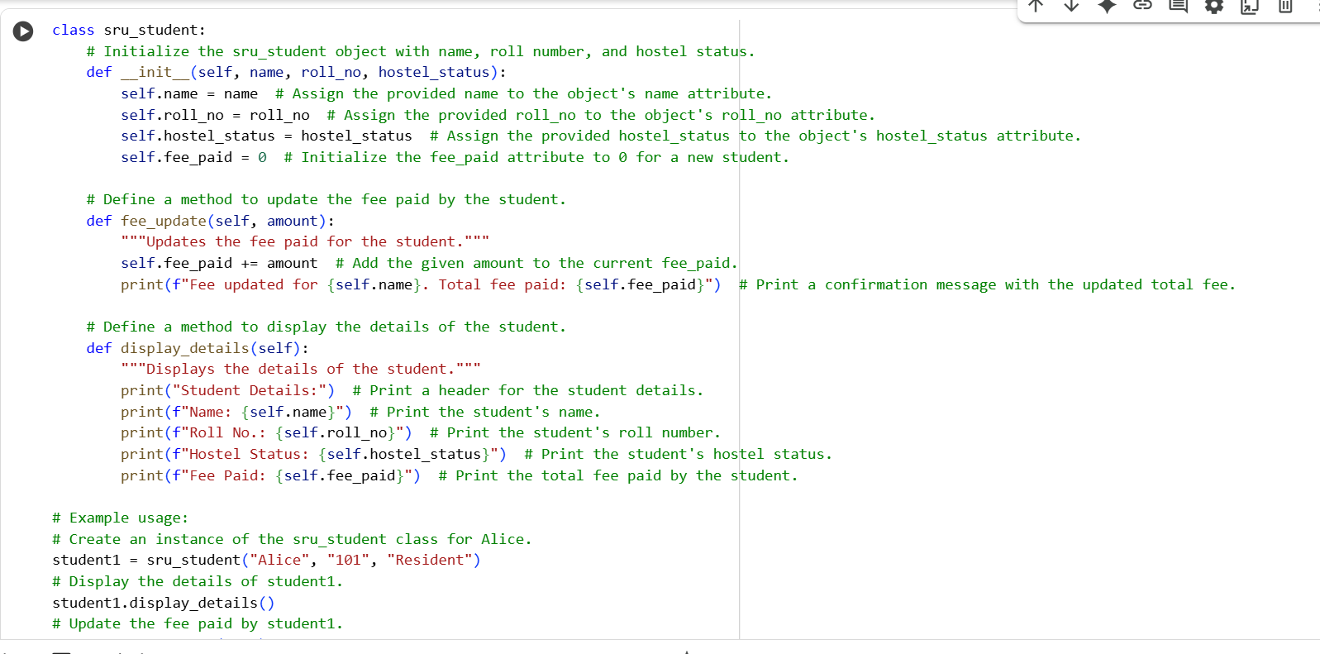

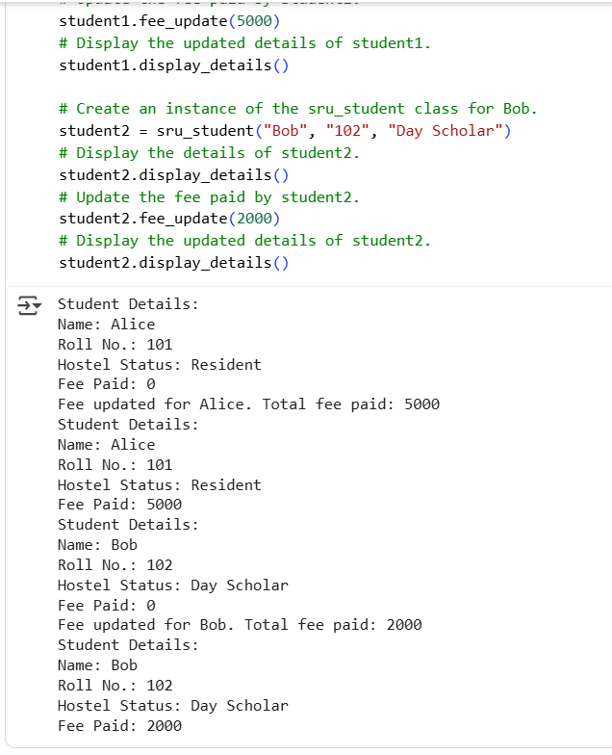

**VS CODE WITHOUT DOCSTRING:**

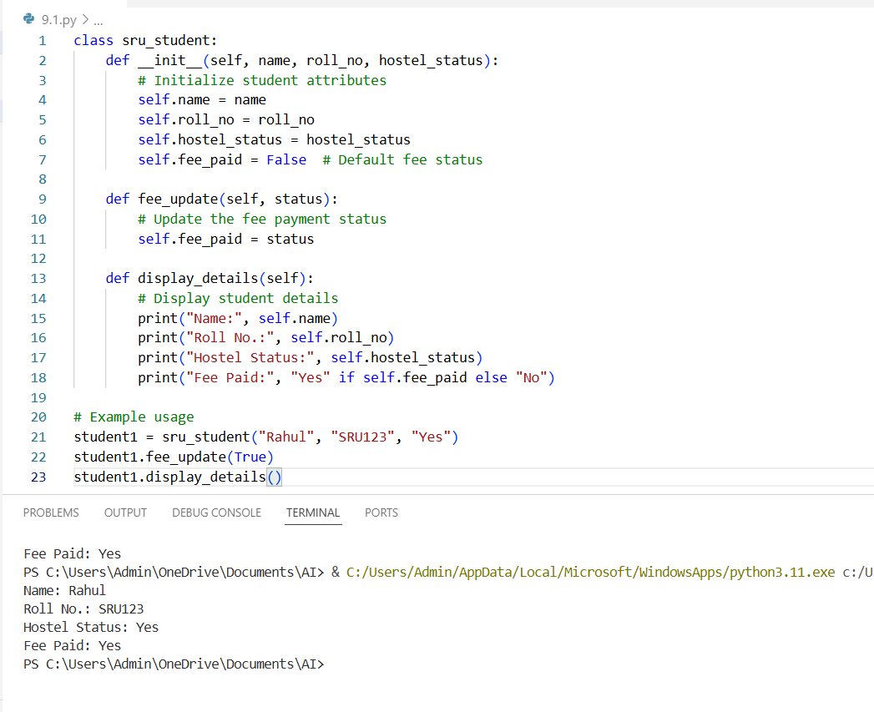

**CODE WITH INLINE COMMENTS AND DOCSTRING:**

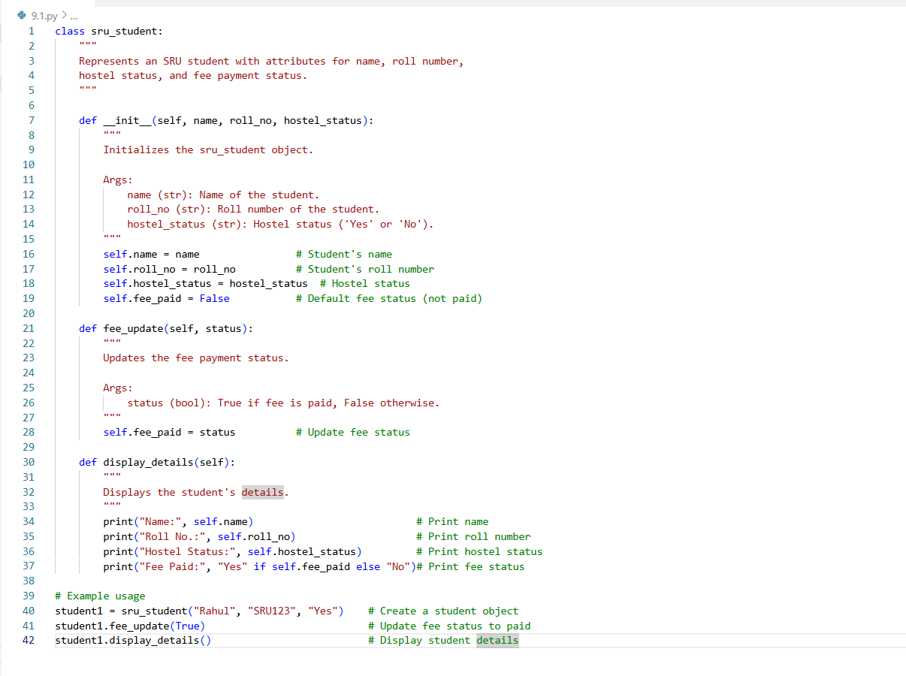

**Output:**

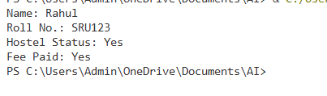

* **TASK-3**

Write a Python script with 3–4 functions (e.g., calculator: add, subtract, multiply, divide).

**GEMINI CODE WITHOUT INLINECOMMENTS AND DOCSTRING :**

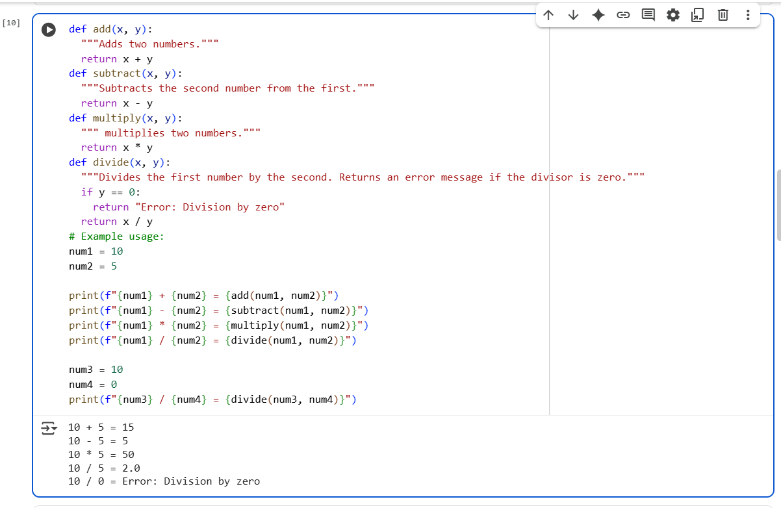

**CODE WITH INLINE COMMENTS AND DOCSTRING:**

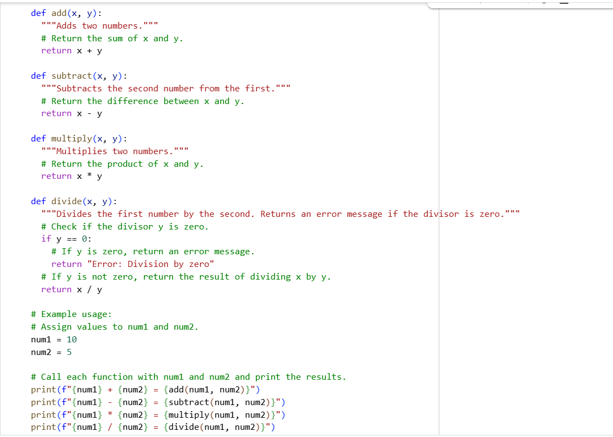

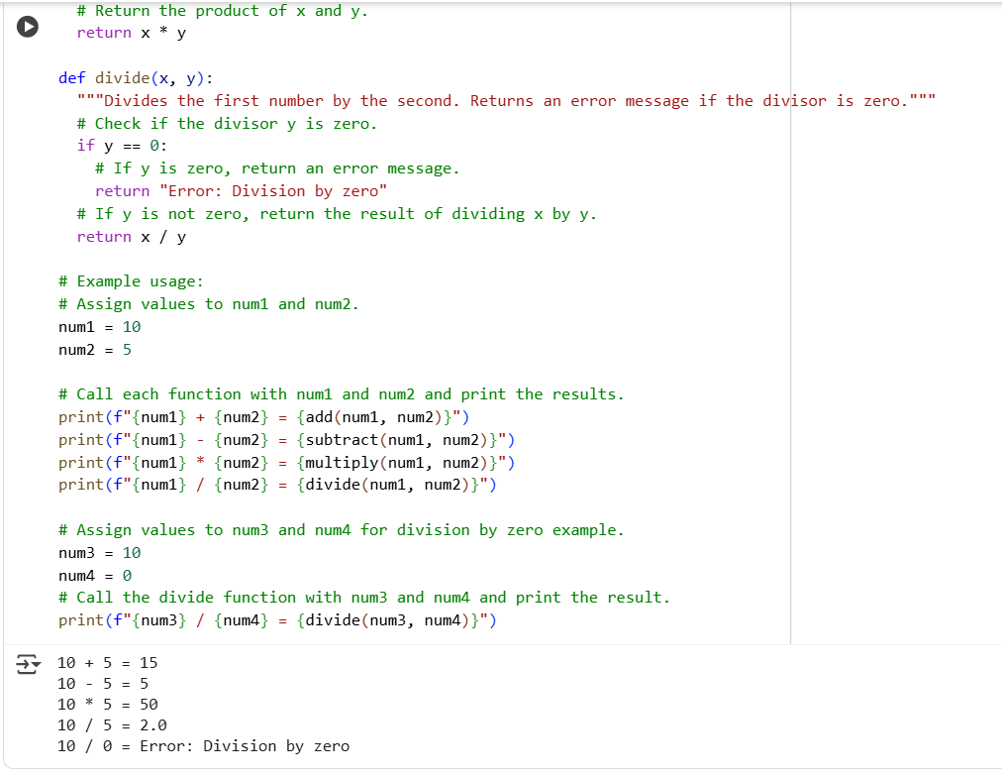

**VS CODE WITHOUT DOCSTRING:**

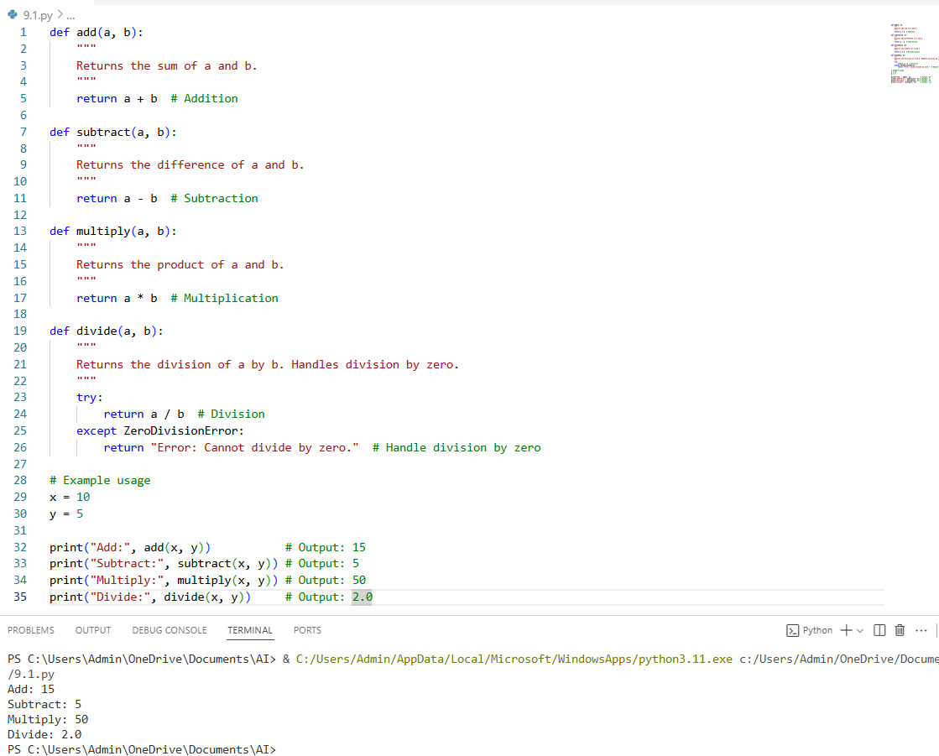

**CODE WITH INLINE COMMENTS AND DOCSTRING:**

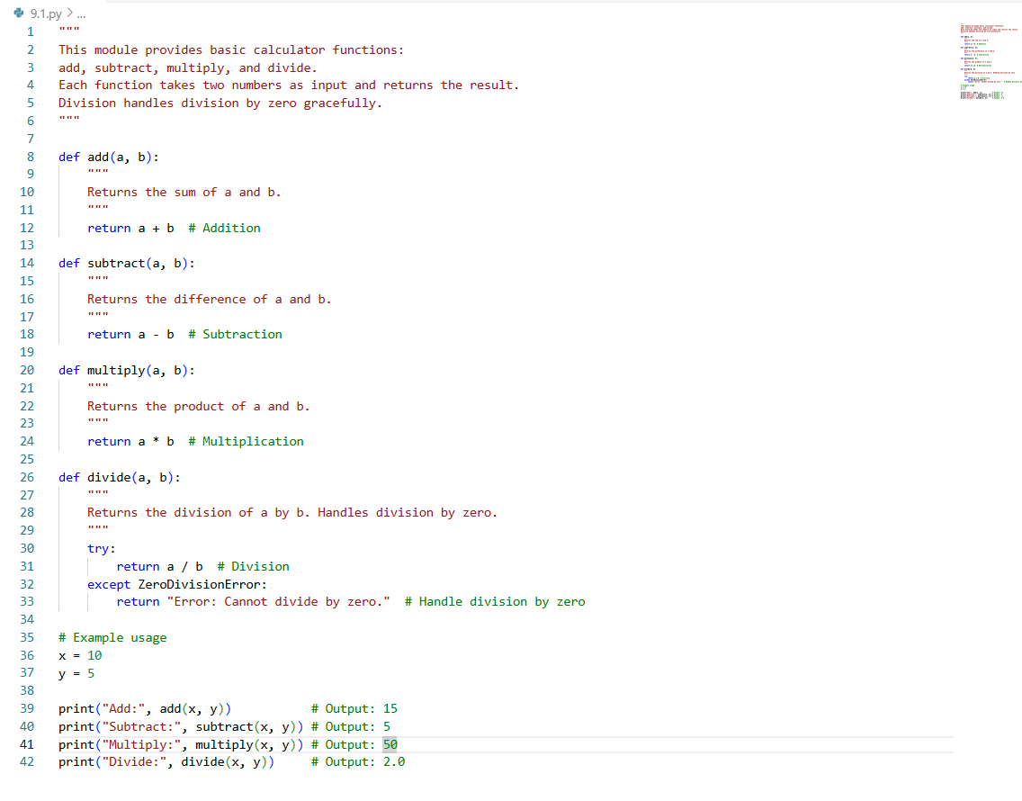

**Output:**

